**BAHRIA UNIVERSITY, Karachi Campus)**

# Department of Software Engineering

# ASSIGNMENT # 03 – Fall 2020

|  |  |  |
| --- | --- | --- |
| Course Title: **Software Construction** |  | Course Code: **SEC-311** |
| Class: **BSE – 5(A/B)** |  | Shift: **Morning** |
| Course Instructor: **Engr. Misbah Perveen** |  | Date: **17th Dec 2020** |
| Due Date: 25**th Dec 2020** |  | Max. Marks: **5.0 Marks** |

**Instructions:**

1. This is a Complex Engineering Problem Assignment.
2. Deadline for the submission of Assignment on is 25th Dec 2020.
3. Hardcopies of the Assignments will be submitted on the same day.
4. If you submit your assignment after the given deadline then 2 Marks will be deducted for the late submissions.

**Question No. 1: [CLO#02, 5.0 marks]**

Considering the following diagram, investigate release management process according to your opinion.

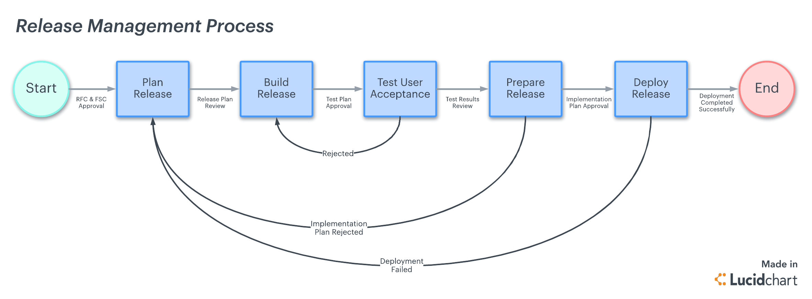

**Solution**

The steps of a software release, from development and testing to deployment, are all under the control of release management. Every time a new product or even improvements to an existing product are needed, release management is necessary. There are five main steps to release management, while the methods may vary and should be tailored for each firm.

**Plan Release:**

The planning phase, when your complete release is organized from beginning to end, may take up the most time. Your team will stay on schedule and make sure standards and requirements are adequately met with the aid of a thorough release plan. A release plan can be approached in a variety of ways. The systems development life cycle is among the most widely used release management techniques (SDLC). With a high level of effectiveness and quality, the SDLC aids software developers in the planning, creation, maintenance, and replacement of software systems. You can use the SDLC in place of or in addition to other project management procedures. The workflow should explain briefly how the whole release is staged and how each team member plays a part. Your release plan should include:

* Timelines
* Delivery dates
* Requirements
* 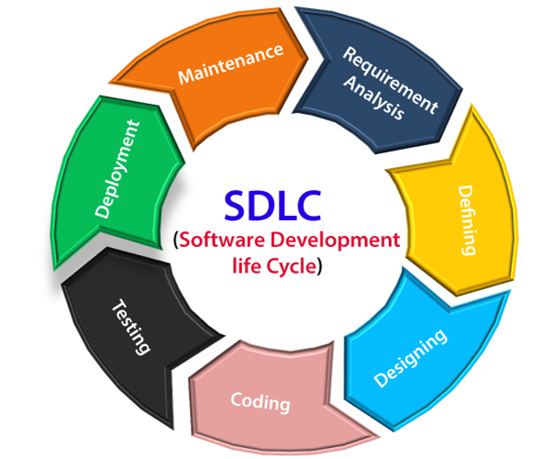The overall scope of the project

**Build Release:**

With the release plan finalized, you can start designing and building the product for release. This is the actual “development” of the product based on the requirements outlined in the release plan. It's time to test the build in real-world scenarios after any potential issues have been resolved.  It can require multiple revisions. The product is deployed (often automatically) to a testing environment as the development team completes it to ensure user acceptability. This enables the team to find any defects or problems that might appear in a real-world setting. The build is sent back for development at stage two as problems are found.

**Test User Acceptance**:

User acceptance testing (UAT) is the point when the end users get to use the product and give feedback. This is often done as shared with a larger group of employees within the company. The most important phase in release management is user acceptability testing because of the amount of data collected and fixes required to get the build to where it needs to be for the official launch.

**Prepare Release**:

In this phase, the product is finalized while considering everything that was discovered during the UAT. The QA team conducts a last quality check as part of the release preparation process. The QA team will do final checks throughout the review to make sure the build complies with the business requirements and minimal acceptable standards specified in the release plan. Although UAT and quality assurance can’t always replicate every scenario that might occur once the product is launched, these steps hopefully fleshed out the most common bugs so that your team can better anticipate and prevent any problems at launch. The functional team will evaluate the findings following the review and prepare the release for deployment.

**Deploy Release**:

In this phase, the product is finalized while considering everything that was discovered during the UAT. A final test is also part of the release process. The development team should convene at the end of the deployment phase to evaluate the performance of the release and go over the deployment process. Any issues that still need to be resolved should be noted and documented for the team to address in the following iteration. Release management is responsible for a dynamic process. As your team learns what roadmap works best for what kind of launch and what doesn't with each release. The collaborative platform makes it easy for team members from developers and product owners to executive stakeholders to view the high-level plan and get at-a-glance insights into their progress, so everyone is on the same page.